GROUP K REPORT
- OTIM JEROME JOEL 2025-B071-13375
- NALUBEGA ANGEL 2025-B201-10750
- NAMARA MODERN 2025-D301-12601 LEADER
- KIGONGO LUWEREKERA 2025-B401-12045
- MODING SAMUEL LOTELLA 2025-B201-10756
- KALYANGO STEWART JUNIOR 2025-B291-13614
THEME: HEALTHY//FITNESS APP
PAGES
HOME PAGE: MODERN
Description: Exercise for fitness growth
ABOUT: KIGONGO LUWEREKA
Description: Leisure Your Valuable Time While Learning Stress Solutions
SERVICES: STEWART
Description: Innovation and Avocations
PORTIFOLIO: MODING SAMUEL LOTELLA/STEWART
Description: Practice makes perfect
FORM: NALUBEGA ANGEL
Description: Cater for life responsibly
BLOG: OTIM JEROME /MODERN
Description: Energy & persistence conquer all things

SCREENSHOTS OF EACHPAGE
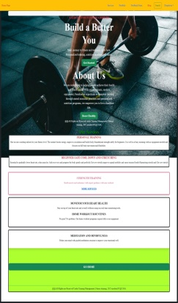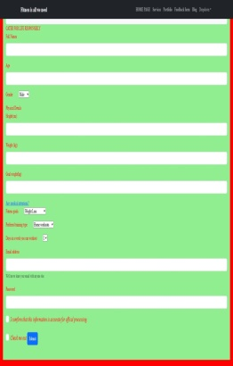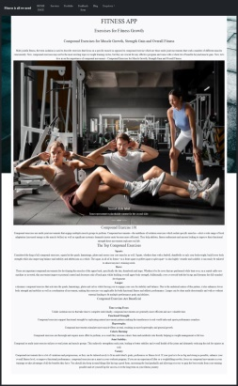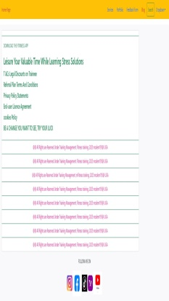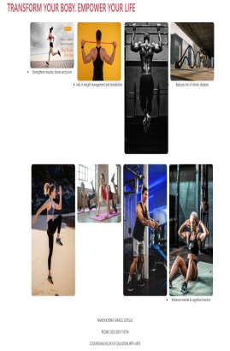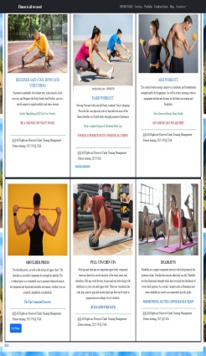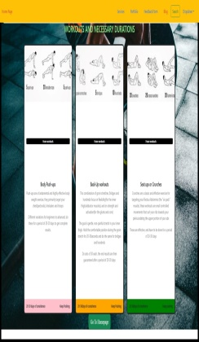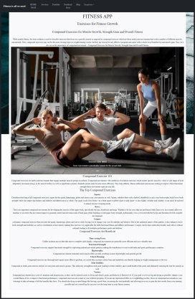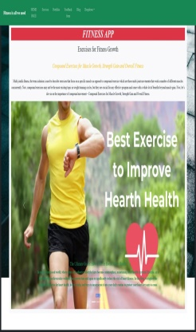
PURPOSES
- Practicing body weighted Squats and Modified Push-Ups keeps you shinning.
- Provides the core physical activity as it delivers most of the fitness.
- Aids recovery and prepares the body gently with Perfectionism like Cat-cow-stretch eases tension
CHALLENGES FACED
- Poor file and folder organization like mixing HTML; CSS, and JavaScript files .
- Data dependence operations, like accessing Bootstrap default HTML, JavaScript, contained online links.
- Modifying Bootstrap’s core CSS directly instead of adding necessary changes in custom files.

